CSA 1507 CLOUD COMPUTING AND BIG DATA ANALYSIS

- Create a simple cloud software application for Flight Reservation System using any Cloud Service Provider to demonstrate SaaS include the necessary fields such as one way, round trip, From, to, Departure, Departure, Travelers &amp; Class, Fare Type, International and Domestic Flights etc.

AIM
To create a simple Flight Reservation System using Python that demonstrates a cloud-based SaaS application with options for domestic and international flights, trip type, travel details, class, and fare type.
PROCEDURE
- Open Python IDLE and create a new Python file.
- Write the Python program using the Tkinter library.
- Design the Flight Reservation System with fields for:
  - One Way / Round Trip
  - Domestic / International
  - From and To
  - Departure and Return Date
  - Travelers
  - Class
  - Fare Type
- Add a Search Flights button to collect the entered details.
- Save the program as flight_reservation.py.
- Run the program using F5 in Python IDLE.
- Enter the flight details and click Search Flights.
- Display the entered reservation details in a confirmation window.

INPUT
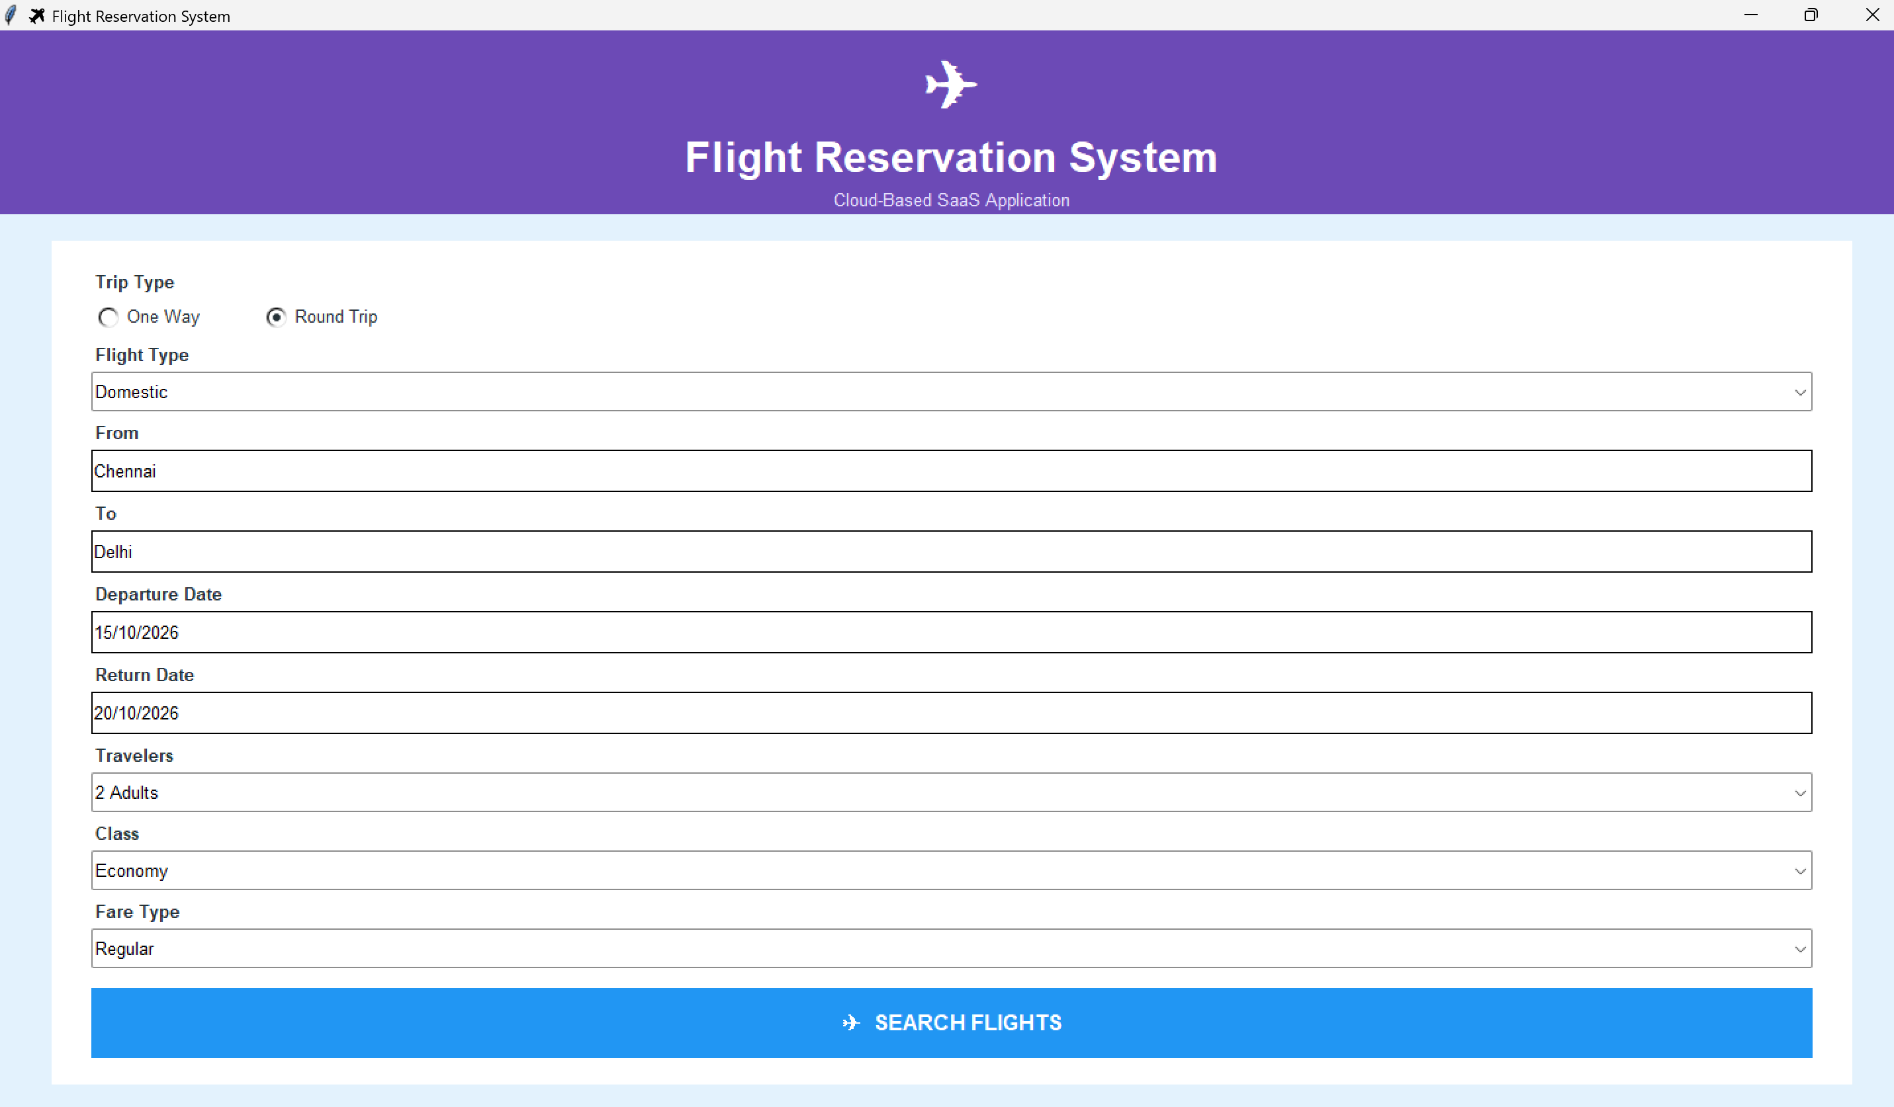
OUTPUT
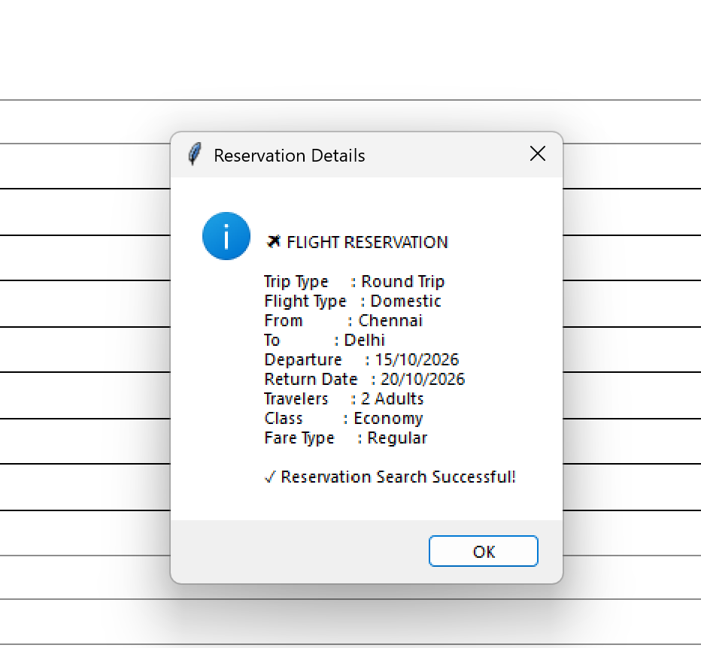

RESULT
The Flight Reservation System was successfully created and executed using Python. The application accepts flight and passenger details and displays the reservation information successfully.
_______________________________________________________________________
2. Create a simple cloud software application for Property Buying &amp; Rental process (In Chennai city) using any Cloud Service Provider to demonstrate SaaS include the necessary fields such as Buy, Rent, commercial, Rental Agreement , Rental Agreement, Area, place, Range, property value etc.
AIM
To create a simple cloud-based Property Buying and Rental System for Chennai city using Python, demonstrating the SaaS model with options for buying, renting, residential and commercial properties.
PROCEDURE
- Open Python IDLE and create a new Python file.
- Write the Python program using the Tkinter library.
- Create fields for:
  - Buy / Rent
  - Residential / Commercial
  - Rental Agreement
  - Area
  - Place in Chennai
  - Price Range
  - Property Value
- Add a Search Property button.
- Save the program as property_chennai.py.
- Run the program using F5.
- Enter or select the required property details.
- Click Search Property.
- Display the entered property details as the search result.

INPUT
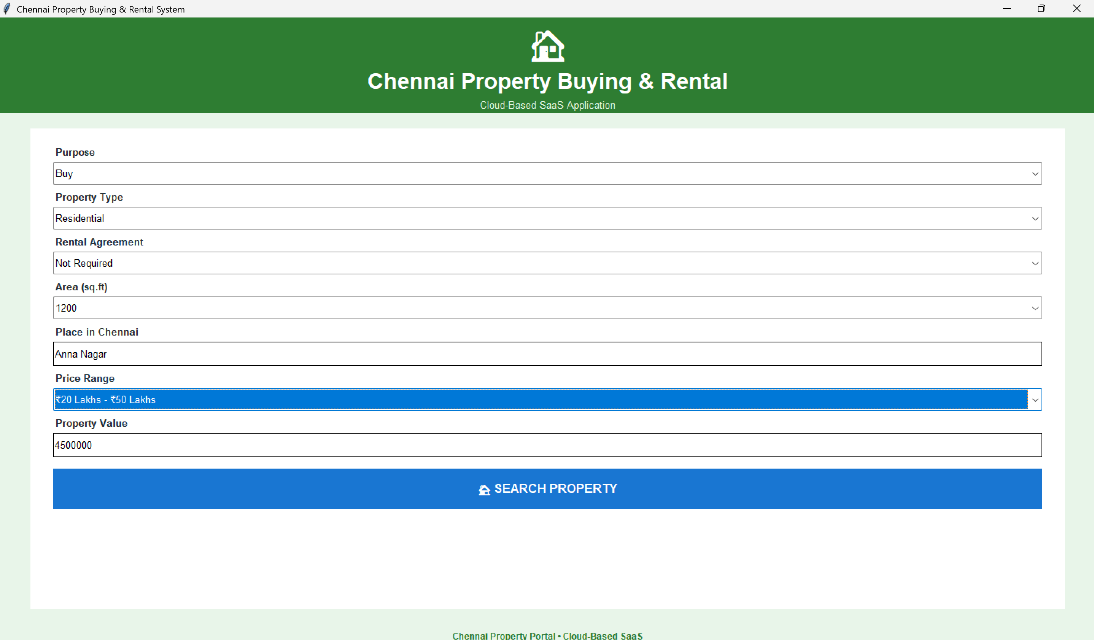
OUTPUT
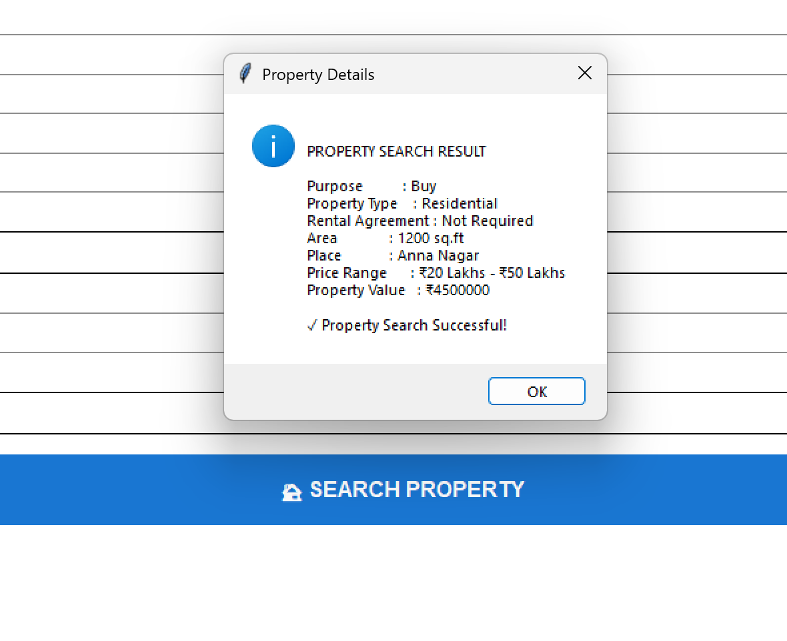
RESULT
The Chennai Property Buying and Rental System was successfully created and executed. The application accepts property details such as buying/renting option, property type, area, location, rental agreement, price range, and property value, and displays the property search result successfully.

3. Create a simple cloud software application for Car Booking Reservation System using
any Cloud Service Provider to demonstrate SaaS include the necessary fields such as
search for cabs, from, to, rental , out station, Package type, hours/Days etc.
AIM
To create a simple Car Booking Reservation System using Python to demonstrate SaaS (Software as a Service) with features such as searching cabs, From, To, Rental, Out Station, Package Type, and Hours/Days.
PROCEDURE
- Open Python IDLE and create a new Python file.
- Import the Tkinter library to create the application interface.
- Create fields for Booking Type, From, To, Package Type, Hours/Days, and Car Type.
- Add a Search for Cabs button to process the booking details.
- Save the program as car_booking.py and run it.
- Enter the required details and click Search for Cabs to display the booking result.
INPUT
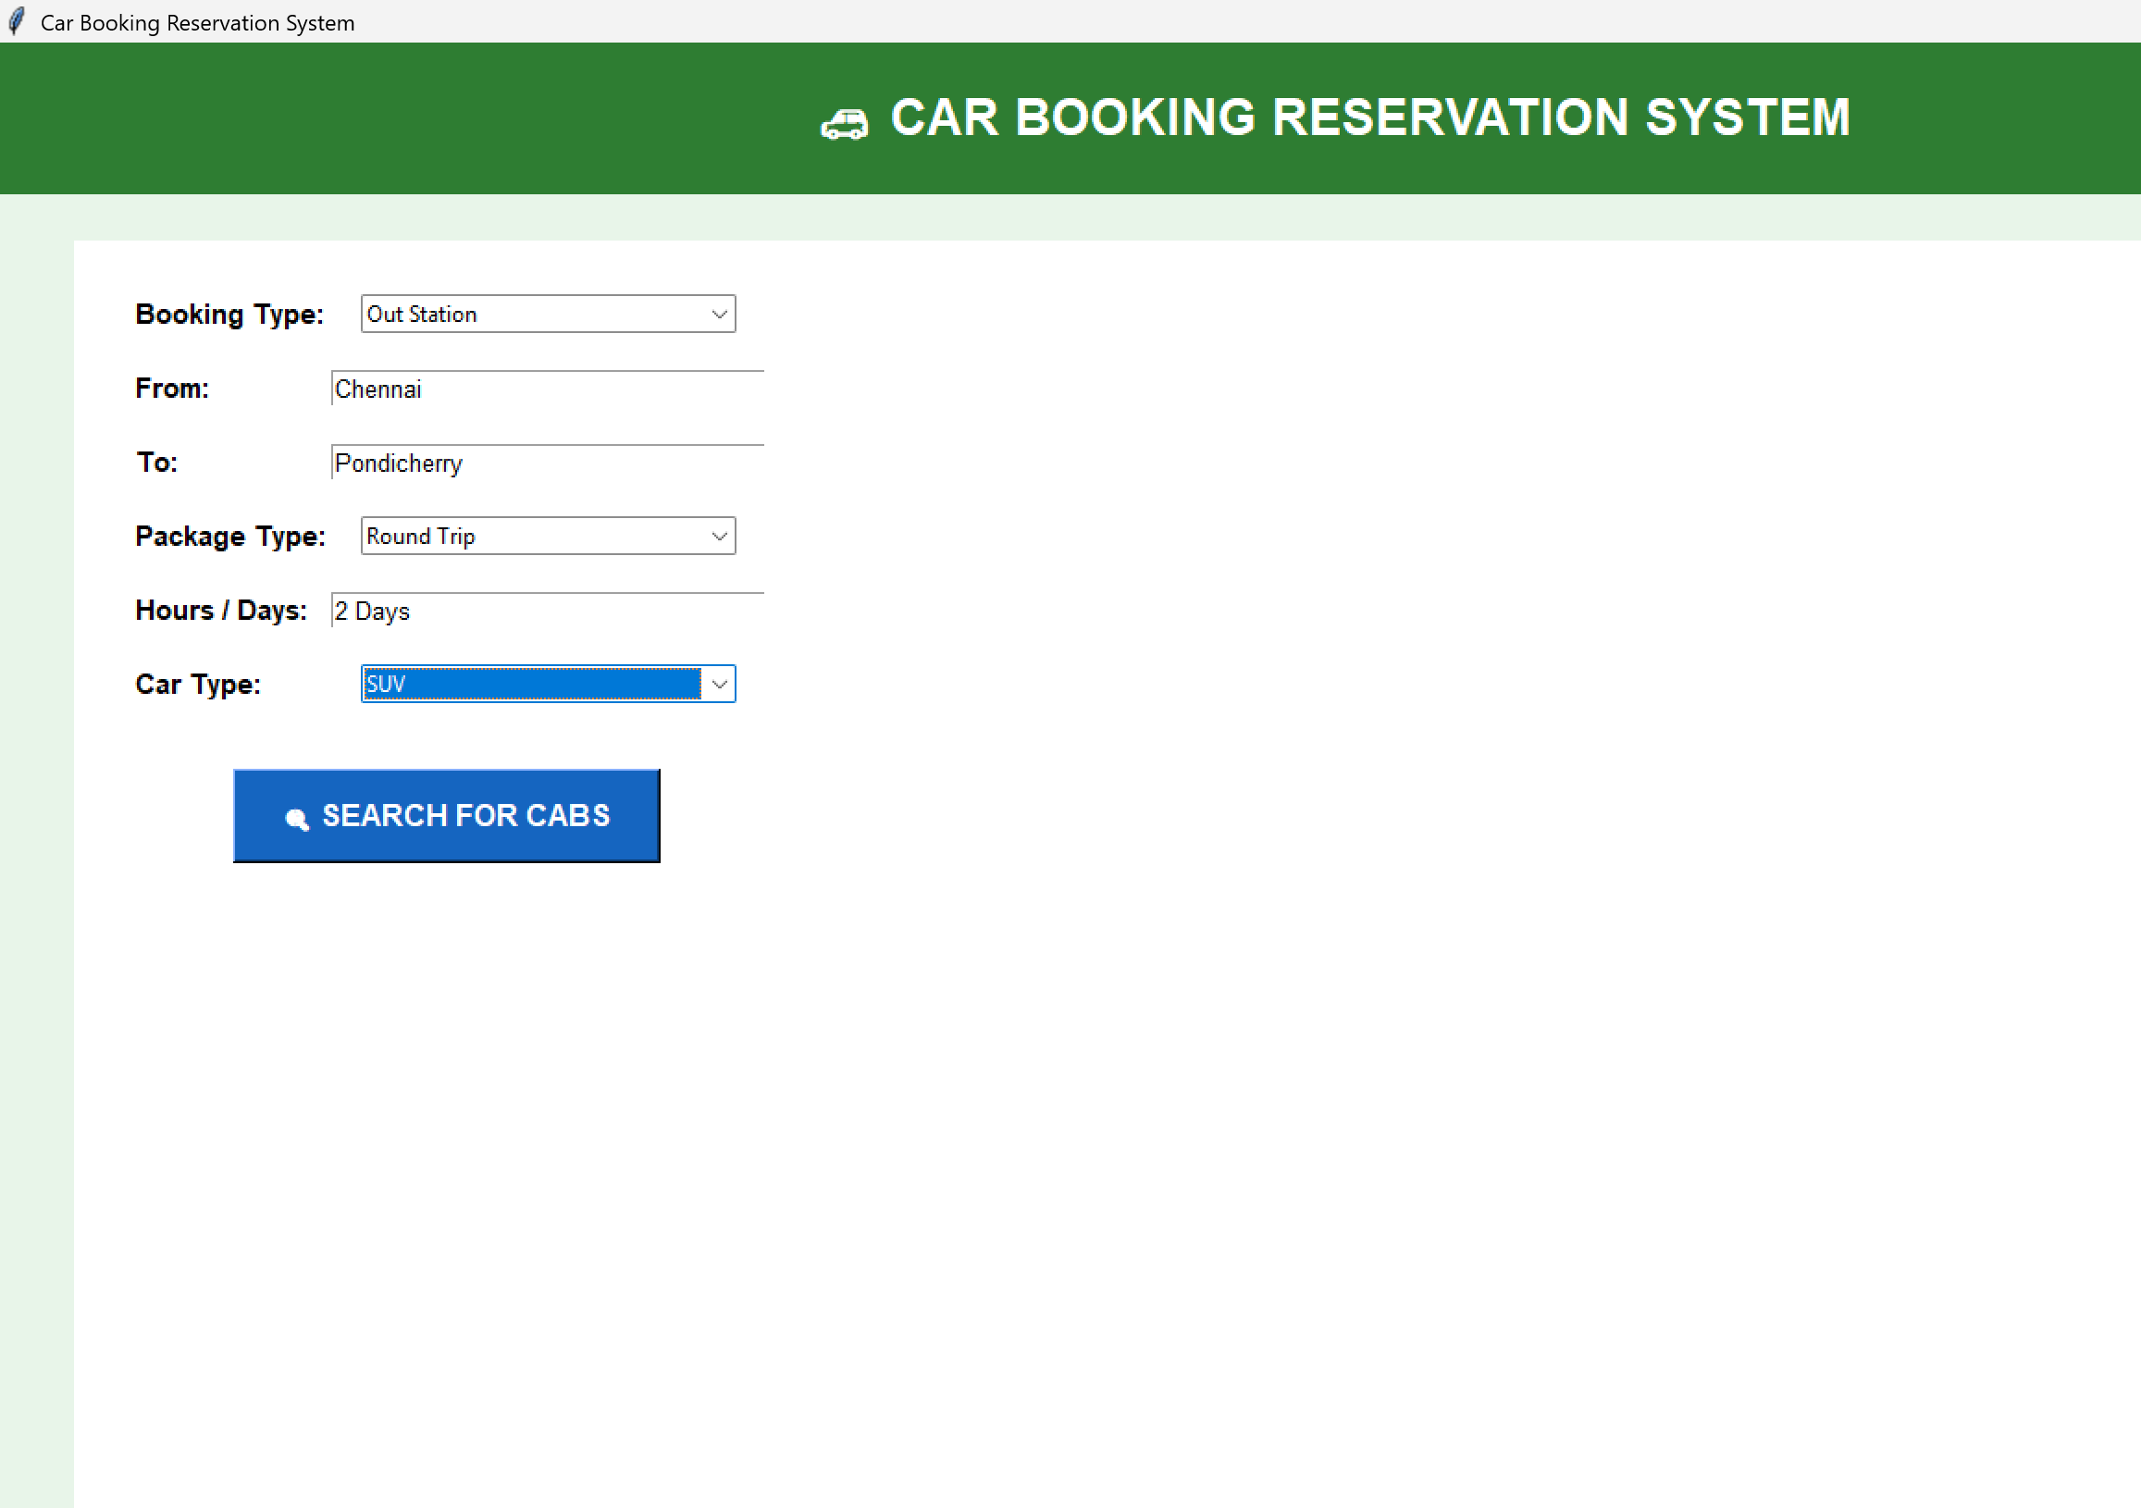

OUTPUT
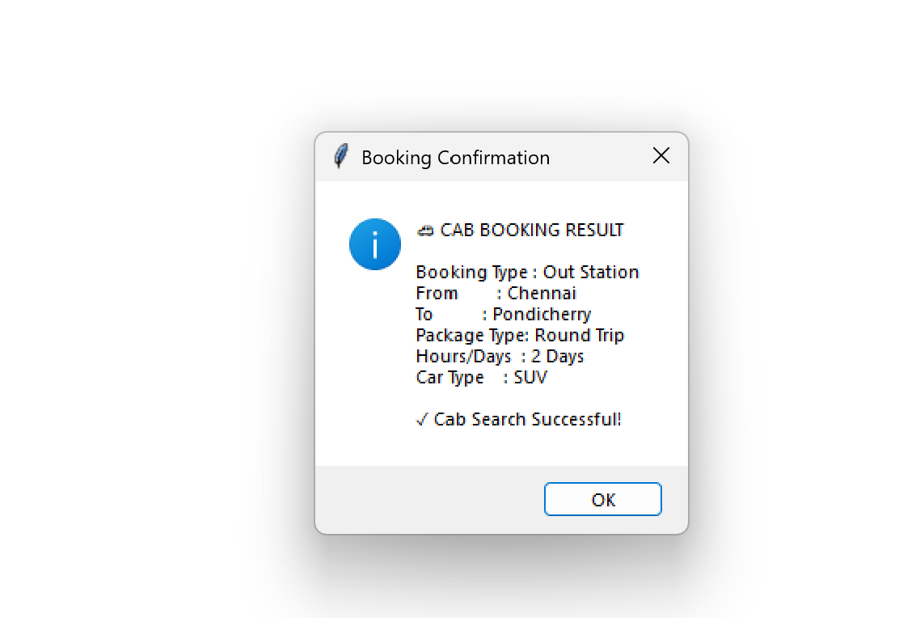
RESULT
The Car Booking Reservation System was successfully created and executed. The application accepts cab booking details and displays the booking/search result successfully.

4. Create a simple cloud software application for Library book reservation system for
SIMATS library using any Cloud Service Provider to demonstrate SaaS include the
necessary fields such as Title of the book, author, publications, Year, edition, no of
copies, Rack no, status (taken/returned) etc.
AIM
To create a simple Library Book Reservation System for SIMATS Library using Python to demonstrate SaaS (Software as a Service) with details such as book title, author, publication, year, edition, number of copies, rack number, and book status.
PROCEDURE
- Open Python IDLE and create a new Python file.
- Import the Tkinter library to create the application interface.
- Create fields for Title, Author, Publication, Year, Edition, No. of Copies, Rack No., and Status.
- Add a Reserve Book button to process the book details.
- Save the program as library_reservation.py and run it.
- Enter the book details and click Reserve Book to display the reservation result.
INPUT
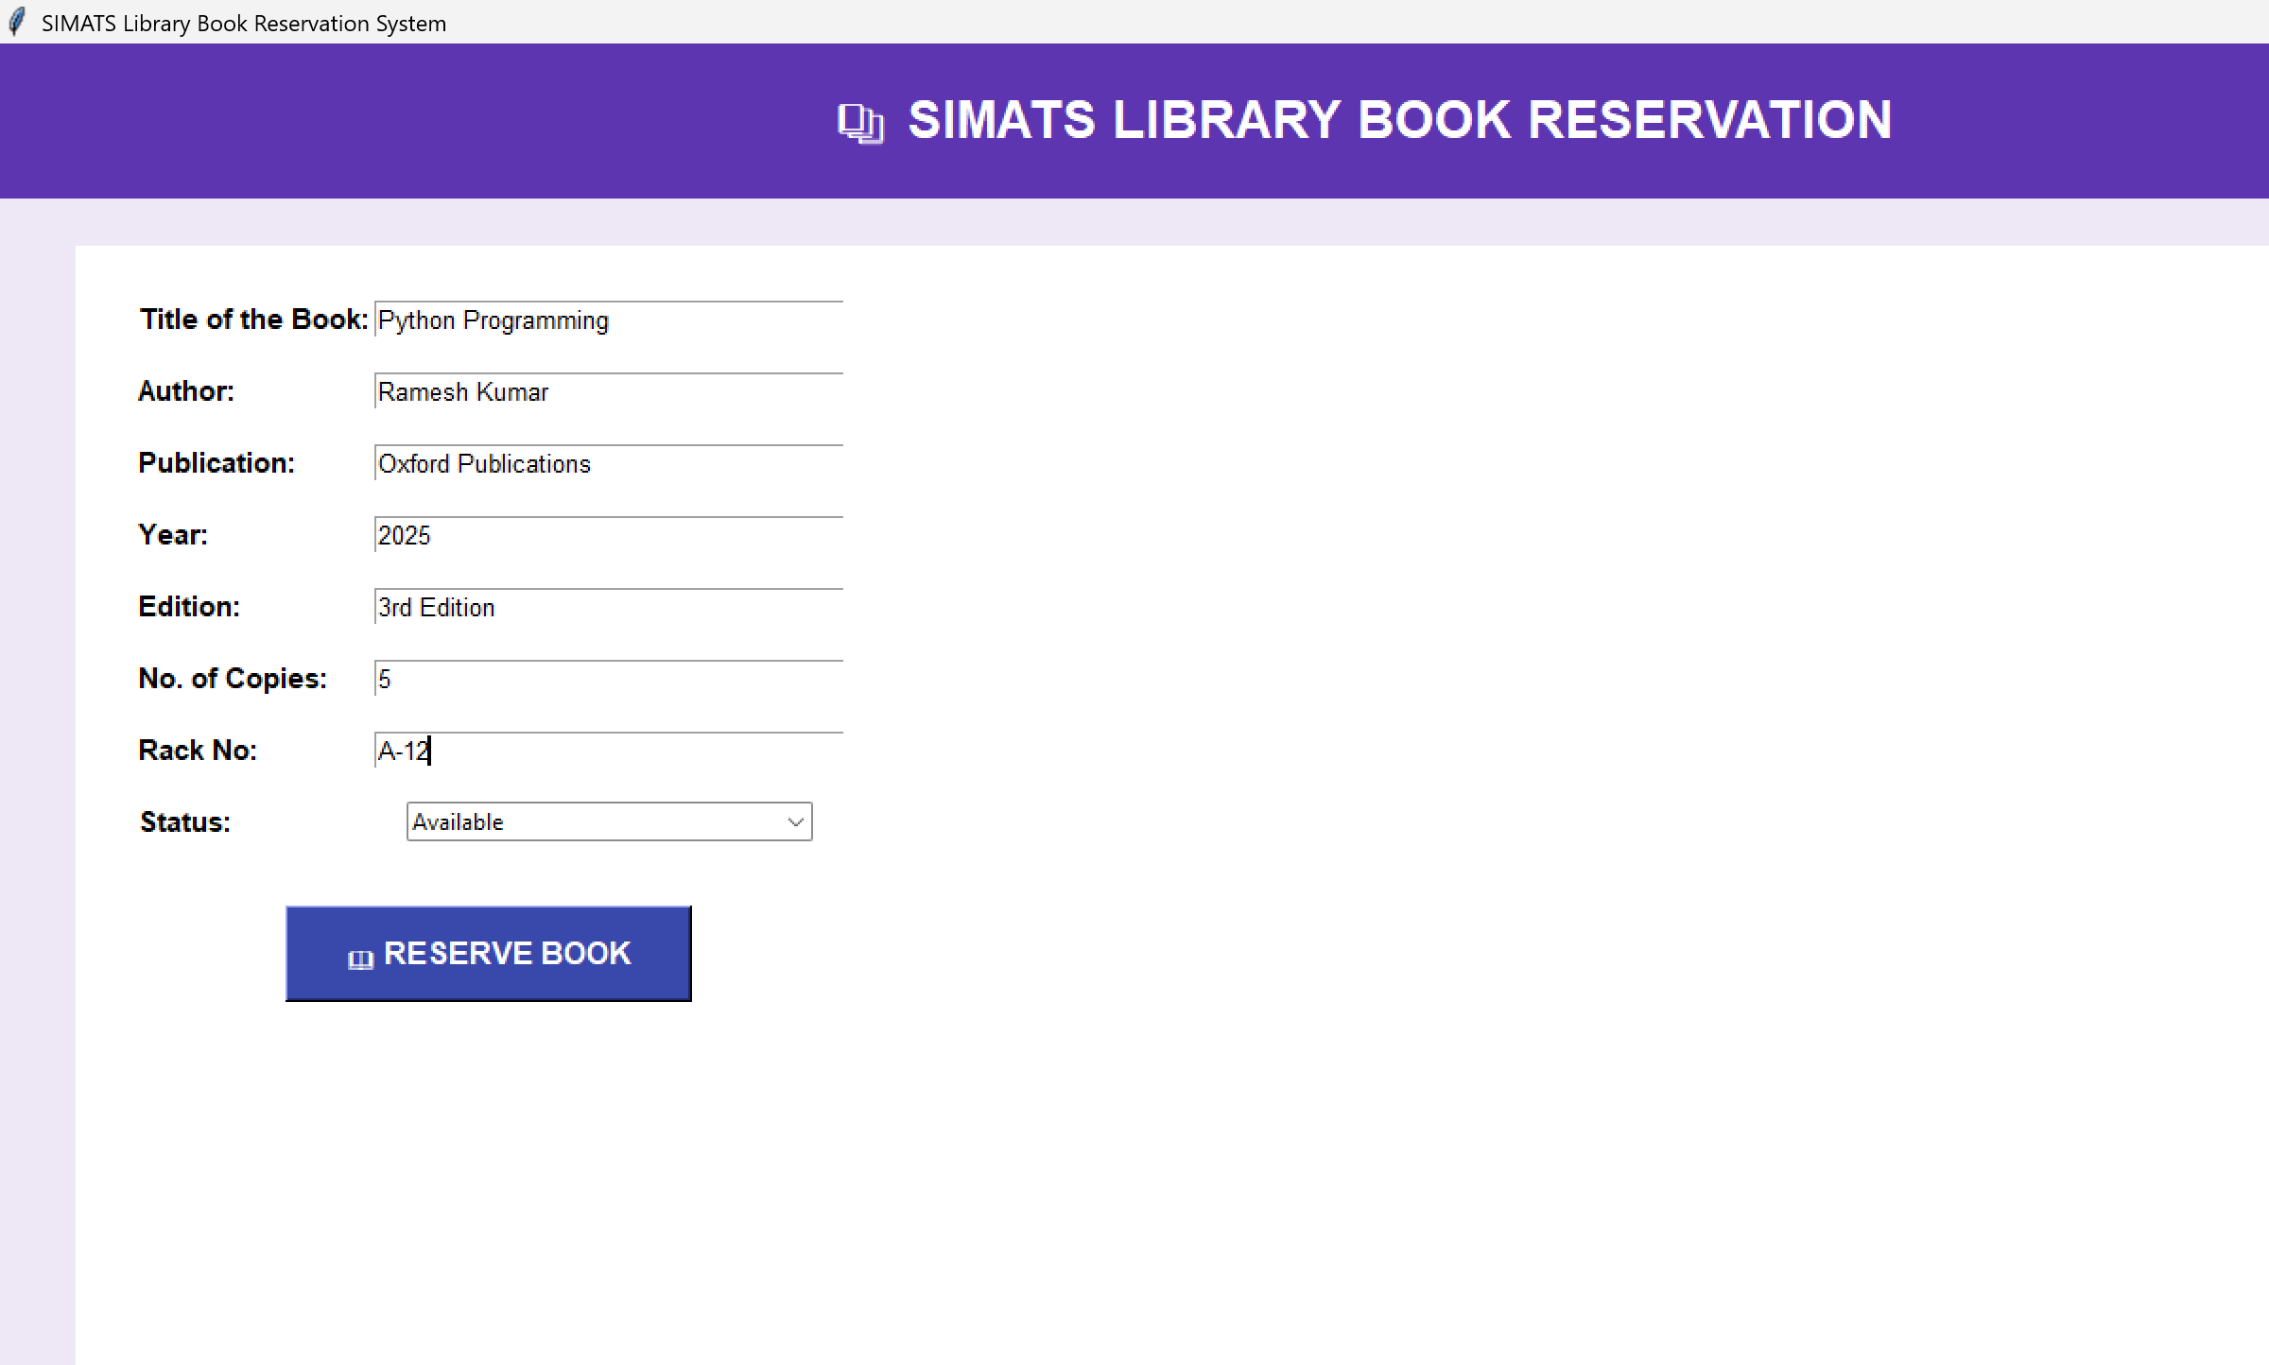
OUTPUT
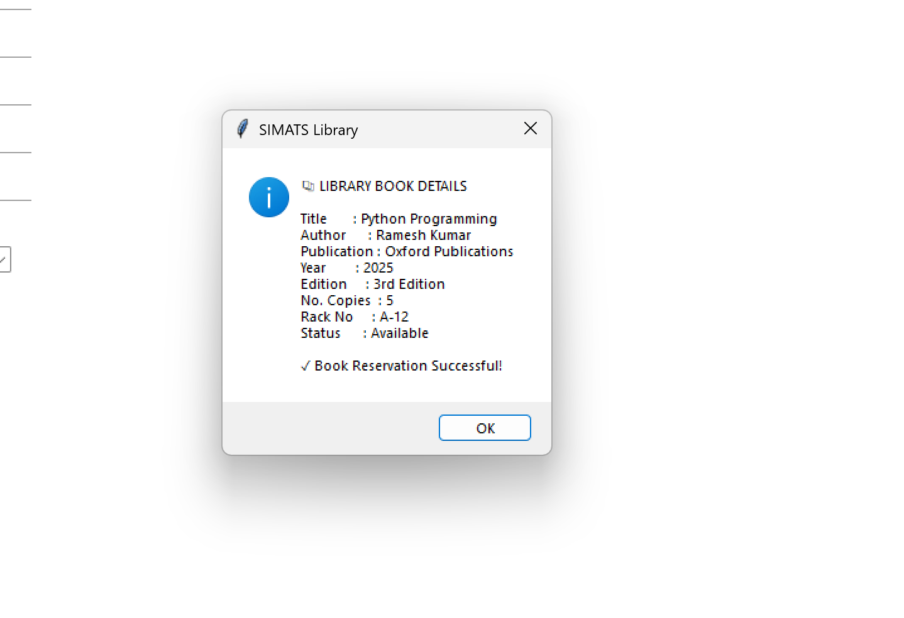
RESULT
The SIMATS Library Book Reservation System was successfully created and executed. The application accepts book details and displays the library book reservation information successfully.

5. Create a simple cloud software application for Mark Sheet Processing System using
any Cloud Service Provider to demonstrate SaaS include the necessary fields such as
name of the student, Reg no of the student , Subjects , Marks, Average, percentage,
rank, overall performance etc.
AIM
To create a simple Mark Sheet Processing System using Python to demonstrate SaaS (Software as a Service) with fields such as student name, register number, subjects, marks, average, percentage, rank, and overall performance.
PROCEDURE
- Open Python IDLE and create a new Python file.
- Import the Tkinter library to create the application interface.
- Create fields for Student Name, Register Number, and Subject Marks.
- Calculate Total, Average, Percentage, Rank, and Overall Performance.
- Add a Process Mark Sheet button to process the student details.
- Save the program as marksheet.py and run it.
- Enter the student details and click the button to display the result.
INPUT
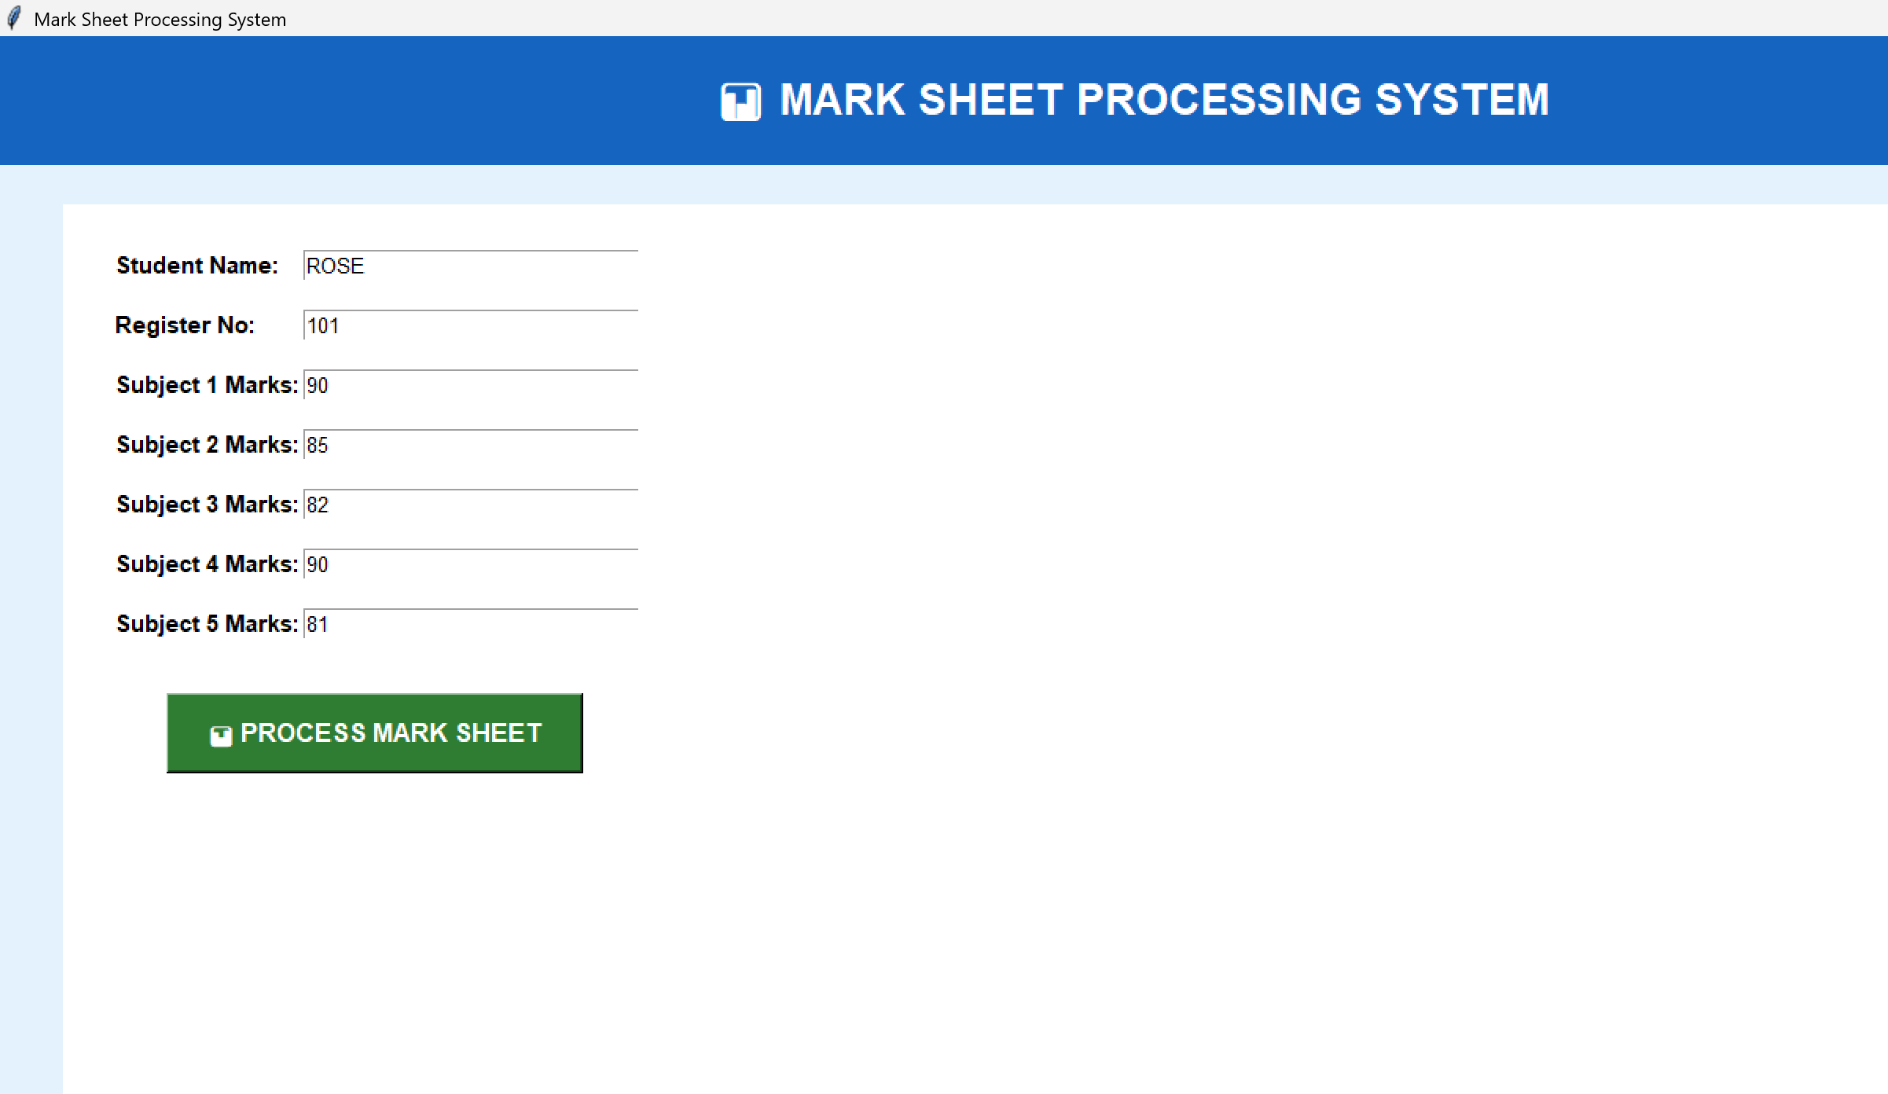

OUTPUT
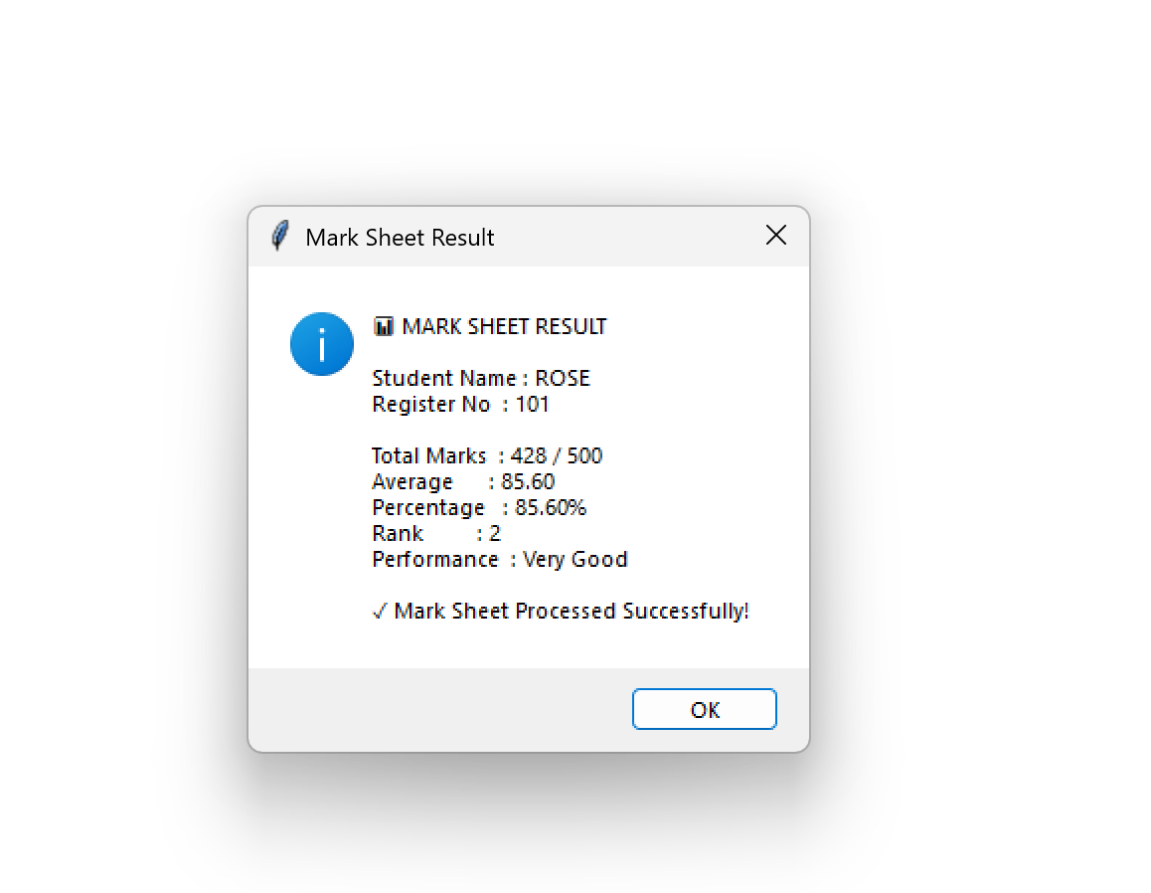
RESULT
The Mark Sheet Processing System was successfully created and executed. The application accepts student marks and successfully calculates and displays the Total, Average, Percentage, Rank, and Overall Performance.

6. Create a simple cloud software application for Payroll Processing System using any
Cloud Service Provider to demonstrate SaaS include the necessary fields such as Name
of the employee, experience in present org , over all experience, basic pay, HRA, DA,
TA, net pay, gross pay etc.
AIM
To create a simple Payroll Processing System using Python to demonstrate SaaS (Software as a Service) with fields such as employee name, experience, basic pay, HRA, DA, TA, gross pay, and net pay.
PROCEDURE
- Open Python IDLE and create a new Python file.
- Import the Tkinter library to create the application interface.
- Create fields for Employee Name, Present Organization Experience, Overall Experience, Basic Pay, HRA, DA, and TA.
- Calculate the Gross Pay and Net Pay using the salary details.
- Add a Process Payroll button to process the employee information.
- Save the program as payroll.py and run it.
- Enter the employee details and click Process Payroll to display the result.
INPUT
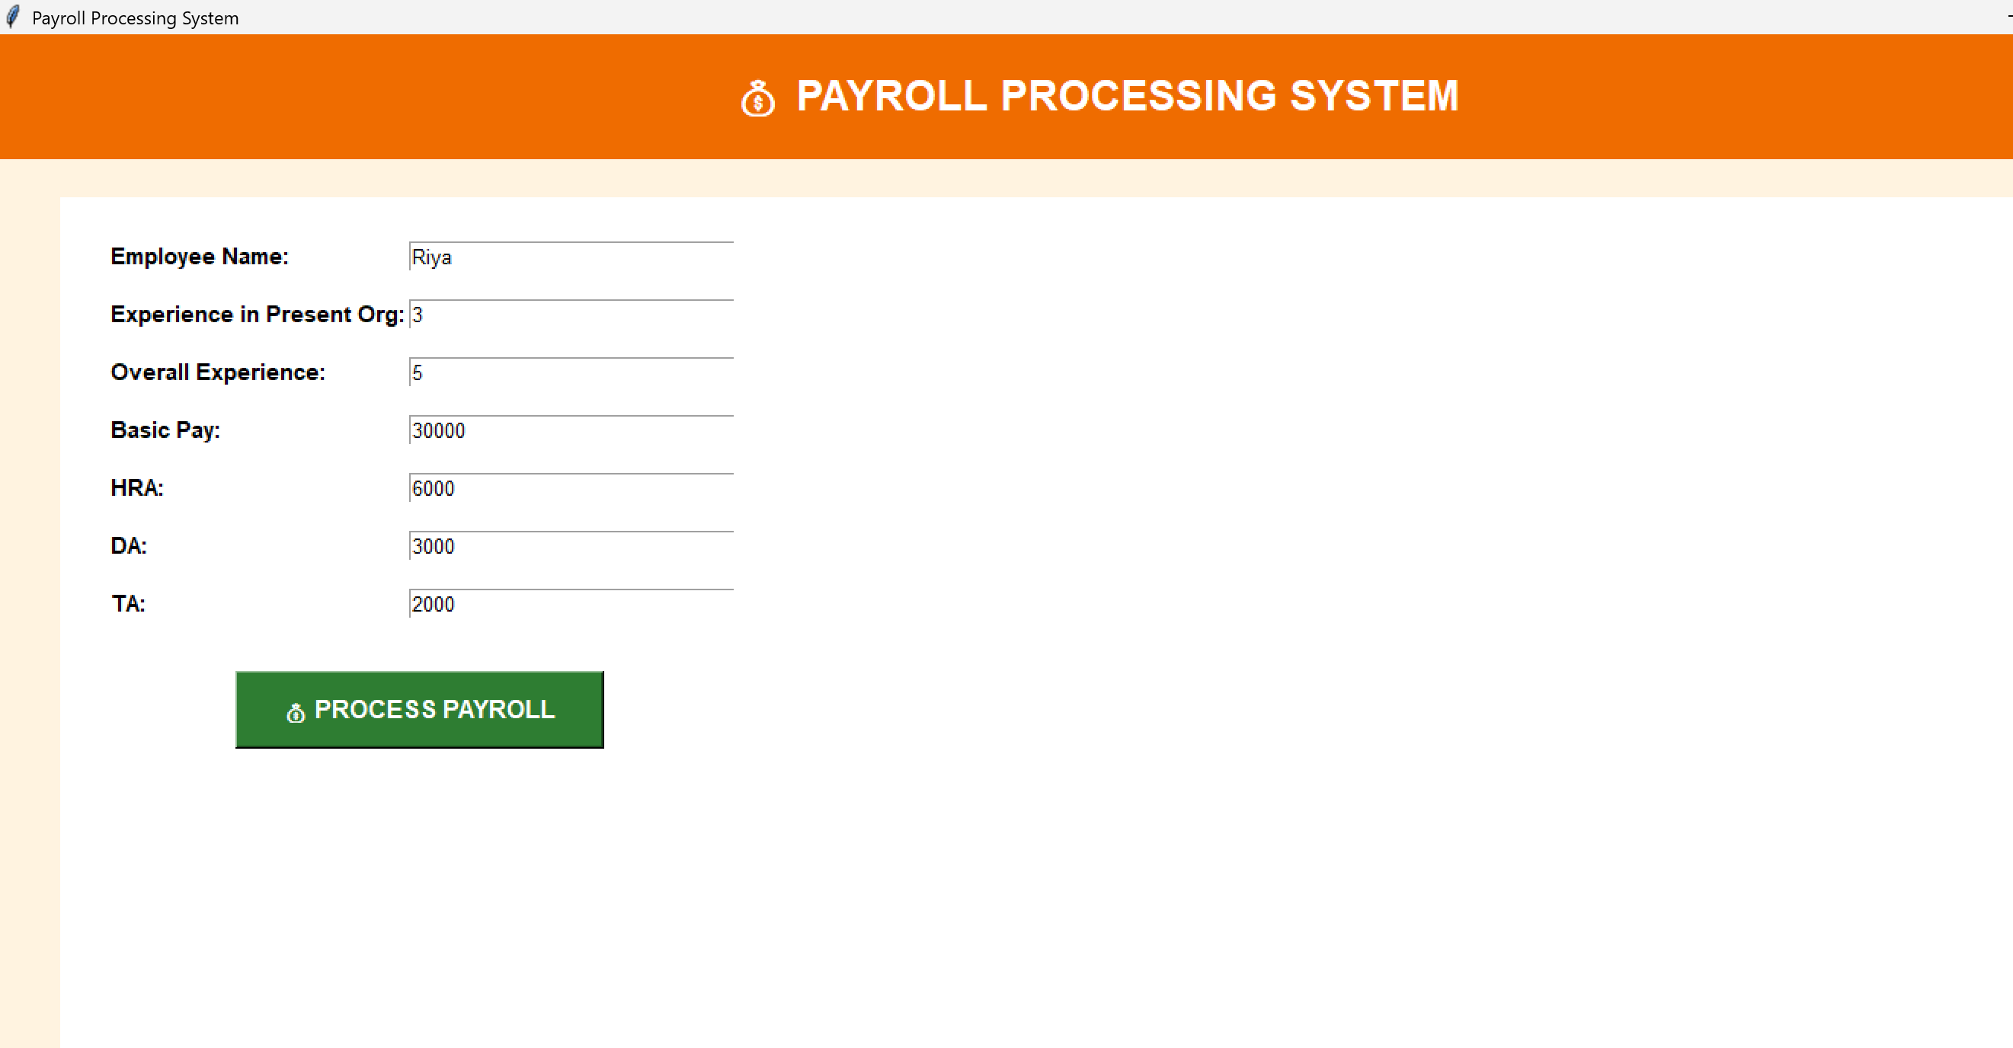
OUTPUT
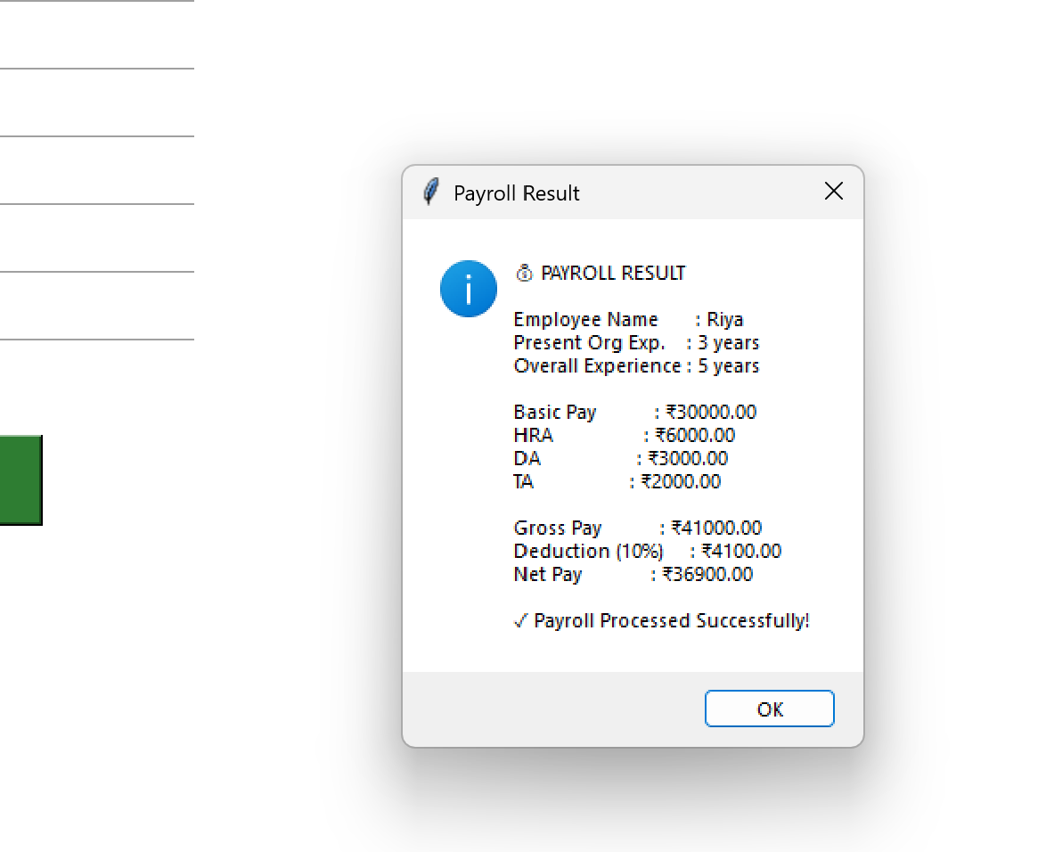

RESULT
The Payroll Processing System was successfully created and executed. The application accepts employee and salary details and successfully calculates and displays the Gross Pay and Net Pay.

7. Create a simple cloud software application for Students Attendance System using any Cloud Service Provider to demonstrate SaaS include the necessary fields such as name of the students, course, present , Absent, course attendance, OD request, grade,
attendance percentage, etc.

AIM
To create a simple Students Attendance System using Python to demonstrate SaaS (Software as a Service) with fields such as student name, course, present, absent, course attendance, OD request, grade, and attendance percentage.

PROCEDURE
- Open Python IDLE and create a new Python file.
- Import the Tkinter library to create the application interface.
- Create fields for Student Name, Course, Present, Absent, OD Request, and Grade.
- Calculate the Attendance Percentage based on the present and absent days.
- Add an Attendance Process button to process the student details.
- Save the program as attendance.py and run it.
- Enter the student details and click the button to display the attendance result.

INPUT

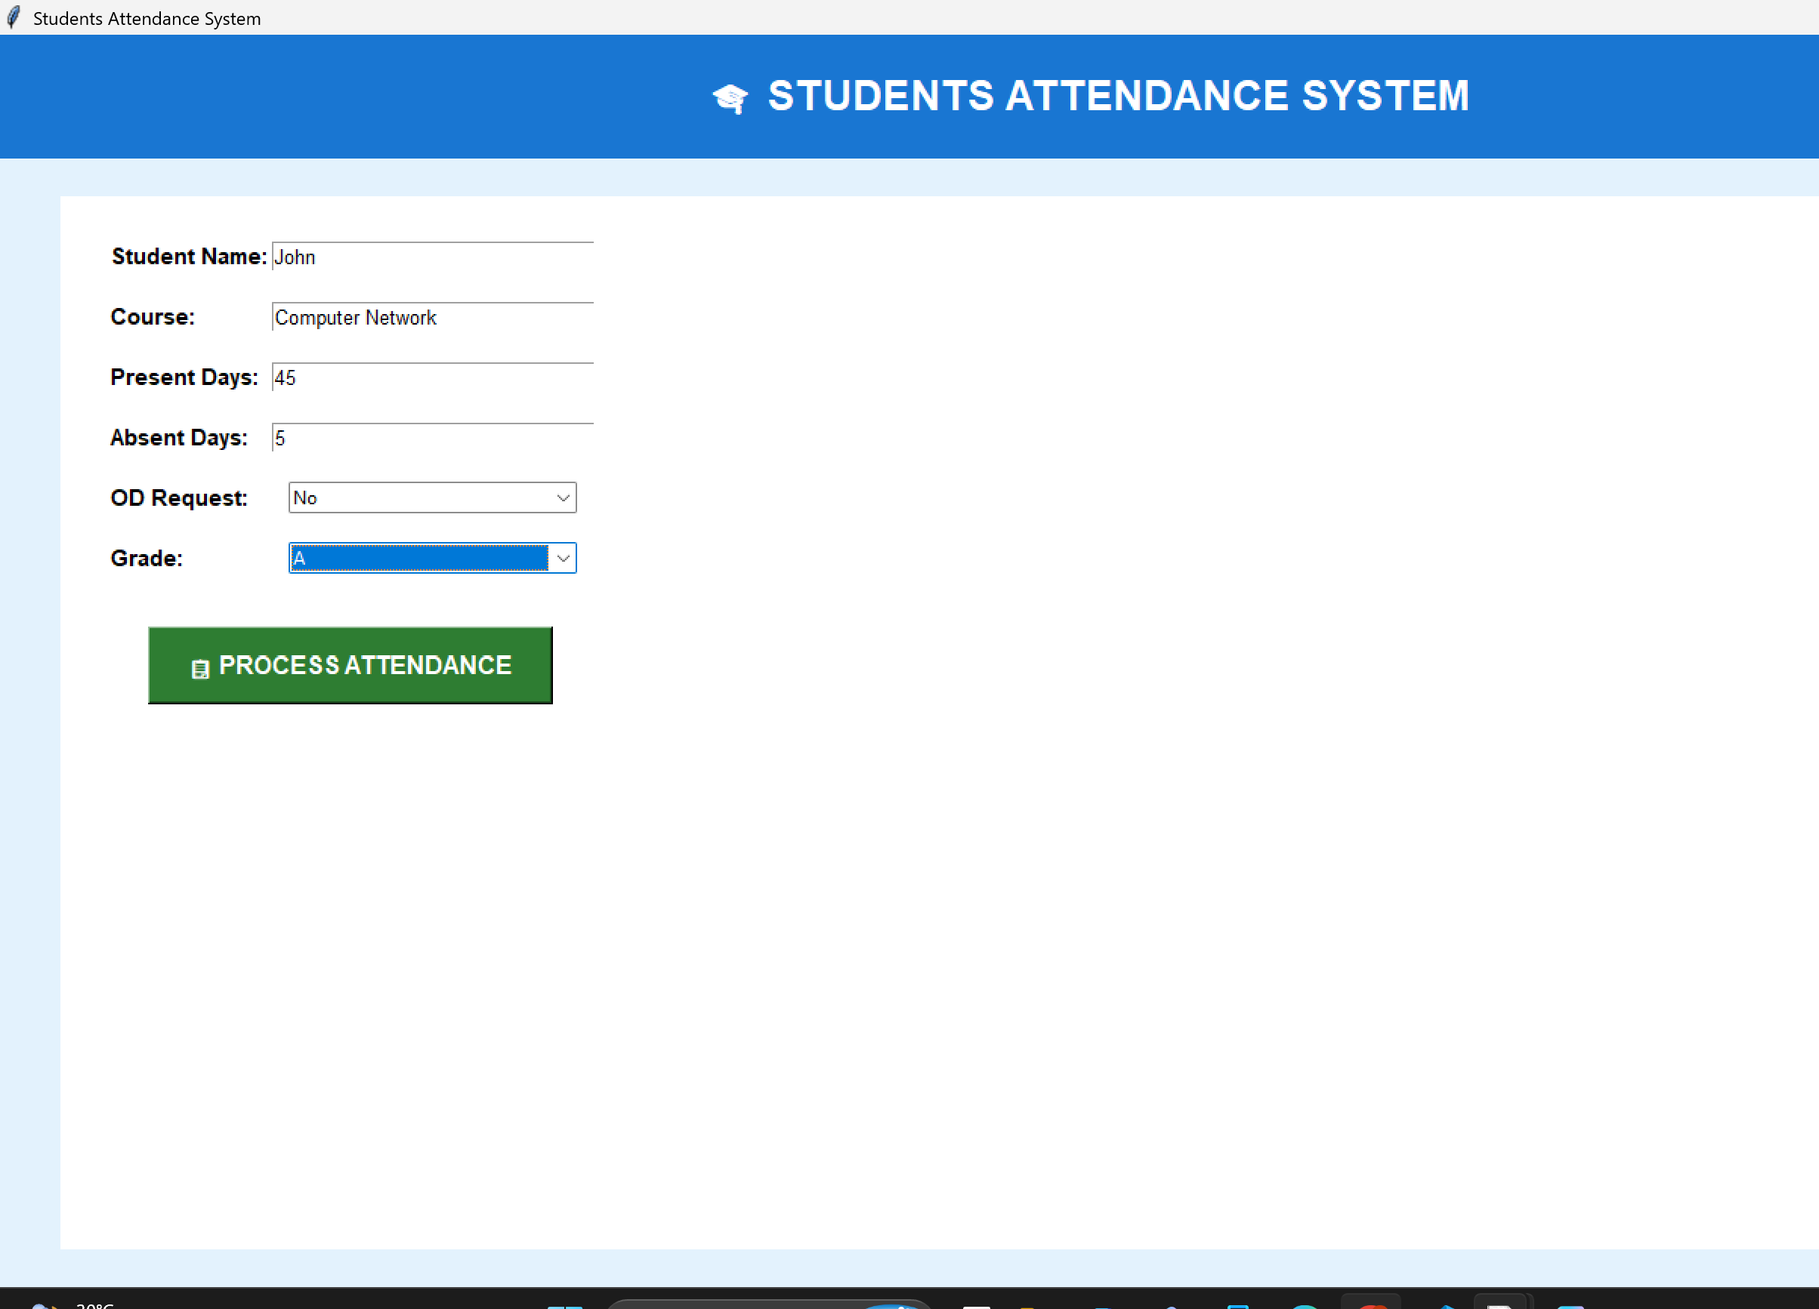

OUTPUT
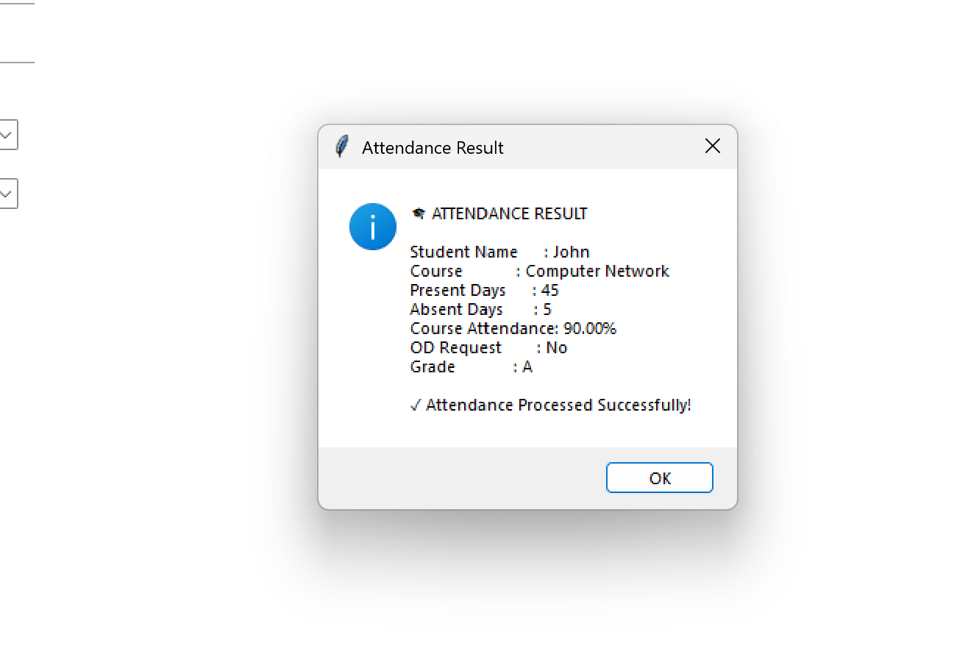

RESULT
The Students Attendance System was successfully created and executed. The application accepts student attendance details and calculates and displays the Attendance Percentage, OD Request, and Grade successfully.

